Problem 24 - C
Integral-2-floating conversion
Recall that IEEE 754 single precision floating-point numbers are of the format depicted below.
1-bit sign s

8-bit exponent e

23-bit fraction f

R

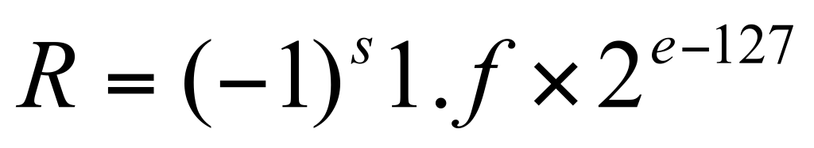, where 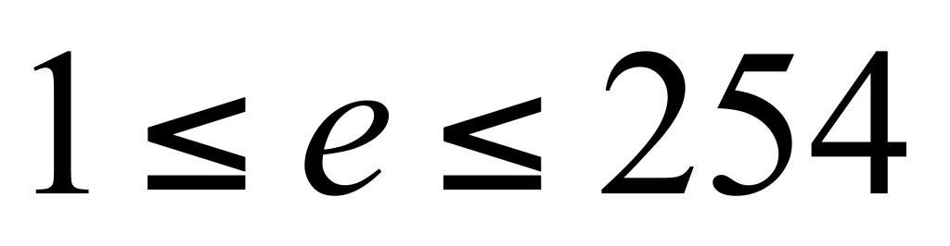.
R = 0, if e = 0 and f = 0
You are asked to convert a given signed integer n to an IEEE 754 single precision floating-point number subject to the following requirements:
1 The 32-bit floating-point number shall be stored in a Boolean array, say, bool a[32]; by treating each Boolean value as a binary digit.
- The result of the conversion is exact, if the corresponding real number n.0 is representable with IEEE 754 single precision format. Otherwise, the result of the conversion shall be rounded down (truncated). For example, there is a 4-bit space to save a number. Now there is a number 11101. The last 1 must be rounded down (truncated), so 1110 will be saved to that space.
- The final conversion result contained in the array may be viewed as a 32-bit binary number. Print it out as an equivalent 11-digit octal number.

Input
The first line of input file contains an integer number M specifying the number of test cases. Each test case consists of a single line which contains a signed integer n. The given signed integer is between -2147483647 and 2147483647.

Output
The output data file contains M lines. Each line consists of an 11-digital octal number which is equivalent to the given number n in IEEE 754 single precision floating-point format. For the i-th case, you should output Case i: followed by a space and the 11-digital octal number in line i.

Sample Input
4
23
123
-123
-23
Sample Output for the Sample Input
Case 1: 10156000000
Case 2: 10275400000
Case 3: 30275400000
Case 4: 30156000000

All inputs are from stdin and outputs to stdout.

